EXERCISE 1

1. What is computer?

A computer is an electronic device that can do a variety of task, including calculations data storage, communication, by processing data and acting upon instructions.

2.What are the essential parts of the computer?

-Central processing unit (CPU): The computer brain, responsible for processing commands and carrying out calculations.

-Memory (RAM): The CPU uses memory as temporary torage to run appplications and process data fast.

-Storage (SSD/Hard Drive): Long term storage for operating system,application and files.

-Motherboard:The primary circuit board that joins and enables communication between all of the parts.

-Power Supply Unit (PSU): Gives power to evry part of the computer.

-INput/Output Devices: These are accessories that conect to a computer, such as keyboard, mouse, monitor, and printer.

-Graphics Processing Unit (GPU): Animated graphics, movies, and still images are rendered by the GPU.

3. Who are the notable inventors of the hardware and softeware?

Cite at least (5) software developers and (5) hardware developers.

Software Developers:

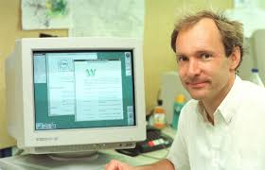1.Tim Berners-Lee: The World Wide Web, created by Tim Berners-Lee, completely changed the way people can access and exchange information on the internet.

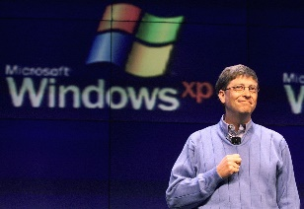2.Bill Gates: Co-founder of Microsoft and instrumental in creating the Windows operating system, which went on to become the standard operating system for personal computers.

3.Linus Torvalds: Developed the widely used open-source Linux operating system, which powers a larger number of modern servers, PCs, and mobile devices.

4.James Gosling: Often referred to be the "father" of Java, this programming language and platform is extensively utilized and essential to mobile and web apps.

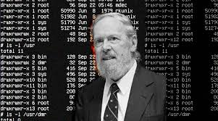5.Dennis Ritchie: Contributed to the invention of the Unix operating system and C programming language, both of which have had a significant influence on contemporary operating systems and software development.

Hardware Developers:

1. Steve Wozniak: Co-founder of Apple Inc. and was responsible for creating the first commercially successful personal computers, the Apple I and Apple II. His creations contributed to the beginneing of the personal computing revolution by making computing accessible to a wider audience.

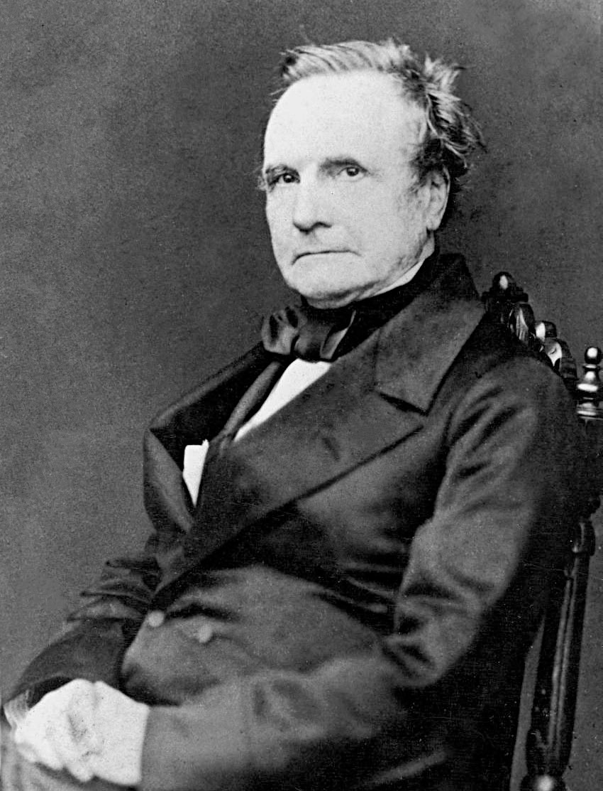2.Charles Babbage: Know as the "father of computer," Babbage created the analythical Engine, the first mechanical computer, int the 1830s. Despite never being finished during his lifetime, his design served as the inspiration for the contemporary computers.

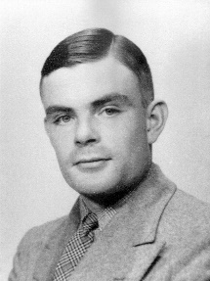3.Alan Turning: Among the pioneers of computer science, Turing was a British mathematician and logician. He created the theoretical Turing machine concept, which served as the model for the digital computer.

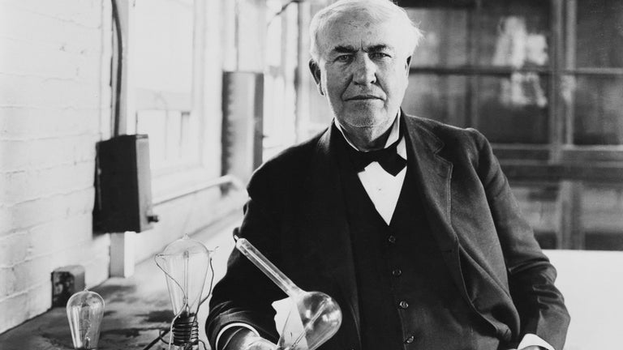4.Thomas Edison: Known for his numerous inventions, which include the lightbulb phonograph, Edison also made contributions to the development of early electrical systems and communication technologies that served as a foundation for the creation of contemporary electronics.

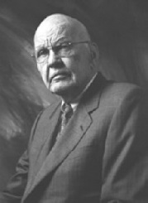5.Jack Kilby: While employed at Texas Instruments, American Engeneer Jack Kilby devised the integrated circuit (IC). Due to its ability to anable the mas manufacturing circuits, this descovery played a pivotal role in the development of contemporary electronics, including computers.

4.Cite your reference/s (APA/IEEE)

https://www.turing.com/blog/famous-computer-scientists-and-their-inventions

https://cointelegraph.com/news/top-10-most-famous-computer-programmers-of-all-time

https://www.gcu.edu/blog/engineering-technology/famous-computer-scientists-throughout-history#h-alan-turing

https://kids.britannica.com/students/article/inventors-at-a-glance/626789